TITLE (Sylfaen: size 12-point, centered paragraph)
First Author ¹ (A. Surname), Second Author ² (B. Surname), Third Author ³ (C. Surname), etc. (11 pt.)
¹First Author′s Affiliation, ²Second Author′s Affiliation, ³Third Author′s Affiliation (10 pt.)
Corresponding author′s e-mail address: john@gmail.com (10 pt.)

Please use the following specifications:
Authors’ names should be written in italics with initials followed by a dot and family name⁄surname; the presenting author should be underlined, and their affiliations (Institution, city, country) should be indicated. The font should be "Sylfaen" throughout the document.
The abstract should be between 200-300 words and 1-page maximum (including figures, tables, and references). Margins should be 3 cm for the top, right, left, and bottom. The body of the abstract should be fully justified. The text-lettering size should be 11 pt. Line spacing 1.

Table 1. All elements need to have captions.

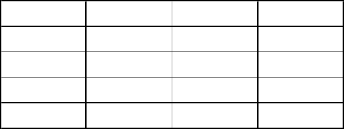

Abstract should be submitted in MS Word format.

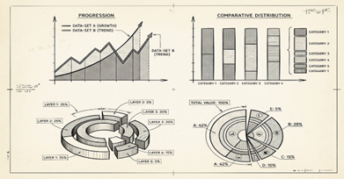
Fig. 1. All elements need to have captions.

References should be the final paragraph and should be cited in the text by square brackets, e.g., [1], (IEEE style) using the proper journal abbreviation.

References: (Font size 11)
[1] J. F. Cotton, R. Smith, J. Chem. Thermodyn. vol (year) page range. (Font size 10)

Cite literature in the original language of publication.

Please name the file of your Abstract using your Surname

Abstracts are accepted including October 15, 2026.

The organizing committee reserves the right to technically edit and translate abstracts; however, they will consult the author/authors if any significant changes are needed.

